

Foundations of Programming
Assignment No.: 10

PROBLEM STATEMENT:
Write a program in C to simulate a simple calculator that performs basic arithmetic operations such as addition, subtraction, multiplication, and division. The calculator should also perform special operations like computing xʸ (power) and x! (factorial).

OBJECTIVE:
• To understand the use of switch-case statements in C.
• To perform basic arithmetic and special mathematical operations.
• To enhance problem-solving skills using menu-driven programs.

THEORY:
A calculator is a basic computing device used to perform arithmetic operations. In C programming, a simple calculator can be implemented using conditional or switch-case statements. Arithmetic operations like addition, subtraction, multiplication, and division are fundamental operations. Special operations such as power (xʸ) and factorial (x!) require loops for repeated calculations.

PLATFORM:
Linux

ALGORITHM:
- Start the program
- Display menu of operations
- Accept user choice
- Use switch-case for operation selection
- For addition, subtraction, multiplication → take two numbers
- For division → check denominator is not zero
- For power → use loop to calculate result
- For factorial → use loop to calculate factorial
- Display result
- Stop

C PROGRAM:

INPUT:
User selects an operation from the menu and enters required values.
Example Input:
Choice: 1
Numbers: 10 20
#include <stdio.h>
int main () {
int choice;
float a, b, result;
int i, n, fact = 1;
printf("Simple Calculator\n");
printf("1. Addition\n2. Subtraction\n3. Multiplication\n4. Division\n5. Power\n6. Factorial\n");
printf("Enter your choice: ");
scanf("%d", &choice);
switch(choice) {
case 1:
printf("Enter two numbers: ");
scanf("%f %f", &a, &b);
result = a + b;
printf("Result = %.2f", result);
break;
case 2:
printf("Enter two numbers: ");
scanf("%f %f", &a, &b);
result = a - b;
printf("Result = %.2f",result) break;

case 3:
printf("Enter two numbers: ");
scanf("%f %f", &a, &b);
result = a * b;
printf("Result = %.2f", result);
break;

case 4:
printf("Enter two numbers: ");
scanf("%f %f", &a, &b);
if(b == 0)
printf("Error! Division by zero");
else {
result = a / b;
printf("Result = %.2f", result);
}
break;

case 5:
printf("Enter base and exponent: ");
scanf("%f %f", &a, &b);
result = 1;
for(i = 1; i <= b; i++) {
result = result * a;
}
printf("Result = %.2f", result);
break;

case 6:
printf("Enter a number: ");
scanf("%d", &n);
for(i = 1; i <= n; i++) {
fact = fact * i;
}
printf("Result = %d", fact);
break;

default:
printf("Invalid choice");
}

return 0;
}
Screen Shot of Input
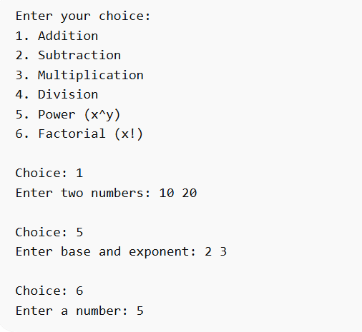

OUTPUT:
Example Output:
Result = 30.00
Screen Shot of Output
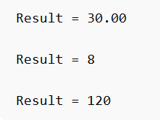

CONCLUSION:
Thus, a simple calculator program was successfully implemented using C programming. The program demonstrates the use of switch-case statements, loops, and arithmetic operations.

FAQs:
- What is a simple calculator program?
- Why is switch–case preferred in calculator programs?
- How does the program handle division by zero?
- How is the power operation (xʸ) implemented without using math library functions?
- What is factorial and how is it calculated using loops in C?

